ĐỀ THI TIẾNG ANH Mã đề: 08
Trình độ A2
Họ và tên thí sinh: ……………..……………………………………………………….…………………………………………………………
Số báo danh: ……………..…………………………………………...……. Phòng thi số: …………………………….……………

PAPER TWO LISTENING (Approximately 15 minutes)
PART 1: Questions 1 – 5
There are five questions in this part. For each question there are three answer choices and a short recording. Tick (√) the correct answer. You will hear the piece twice.
Example: How many people were at the meeting?
A. 3 B. 13 √ C. 30
1. What doesn’t the girl like about her picture?
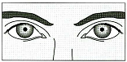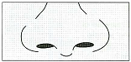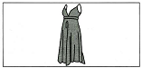
A □ B □ C
2. Which is the boy’s next lesson?
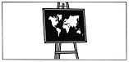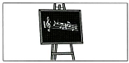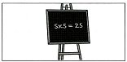
A □ B □ C □
3. What will the man do first?
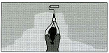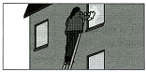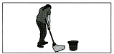
A □ B □ C □
4. What do they need to buy for dinner?
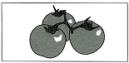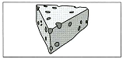
A □ B □ C □
5. What did Joe get for his birthday?
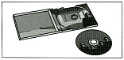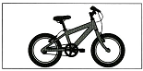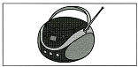
A □ B □ C □

PART 2: Questions 6-10
Listen to Liz and Michael talking about rooms in a hotel. They are going to paint the rooms.
What colour are they going to paint each room?
For questions 6-10, write a letter A-H next to each room. You will hear the conversation twice.

EXAMPLE | ANSWER
0 dining room | G
ROOMS |  | COLOURS
6 television room  7 first floor bedrooms  8 second floor bedrooms  9 office  10 kitchen |  | A dark blue  B light blue  C dark green  D light green  E grey  F red  G white  H light yellow

PART 3: Questions 11-15
Listen to Sue talking to her friend, Jim, about the new sports centre.
For questions 11-15, tick (√) A, B, or C. You will hear the conversation twice.
Example: 0. The new sports centre is
A. cheap
B. big
C. dark
11. Which bus goes to the sports centre?
A. 15
B. 18
C. 25
12. From Monday to Saturday, the sports centre is open from
A. 6 a.m
B. 7 a.m
C. 9 a.m
13. If Sue goes swimming, she must take
A. soap
B. a swimming hat
C. a towel
14. At the sports centre, you can buy
A. sandwiches
B. fruit
C. drinks
15. Jim and Sue are going to go to the sports centre next
A. Wednesday
B. Thursday
C. Saturday

